Geometric Proportionality

Definition
# Source: AI Source: Provided by: [Data Path: Persons Table -> ID Column: 1, Name_En Column: Motasem Essam] -> From: [ChatGPT] on [7/25/2026]
Geometric Proportionality is a geometric relationship in which two or more lengths, distances, areas, or other geometric quantities are related by a constant ratio.
In simple terms, two quantities are proportional when one changes by a constant factor relative to the other.
If two quantities $a$ and $b$ are proportional:
$$\boxed{\frac{a}{b}=k}$$
where $k$ is the constant of proportionality.
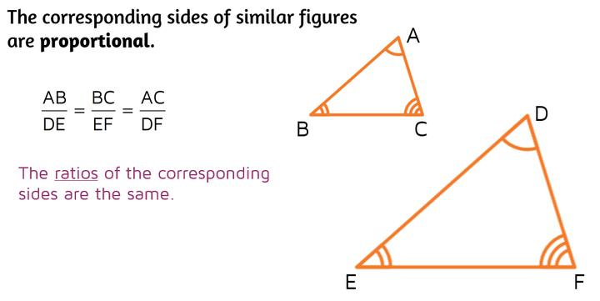
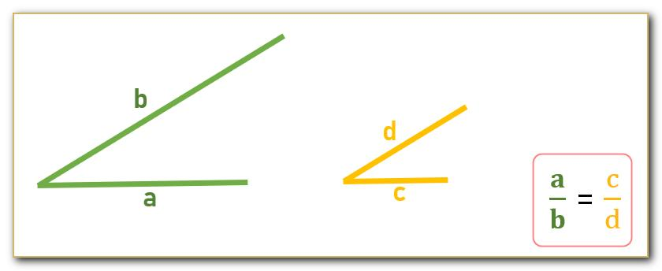
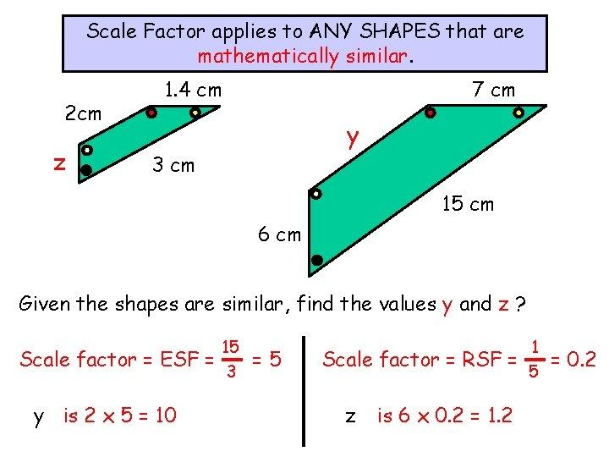
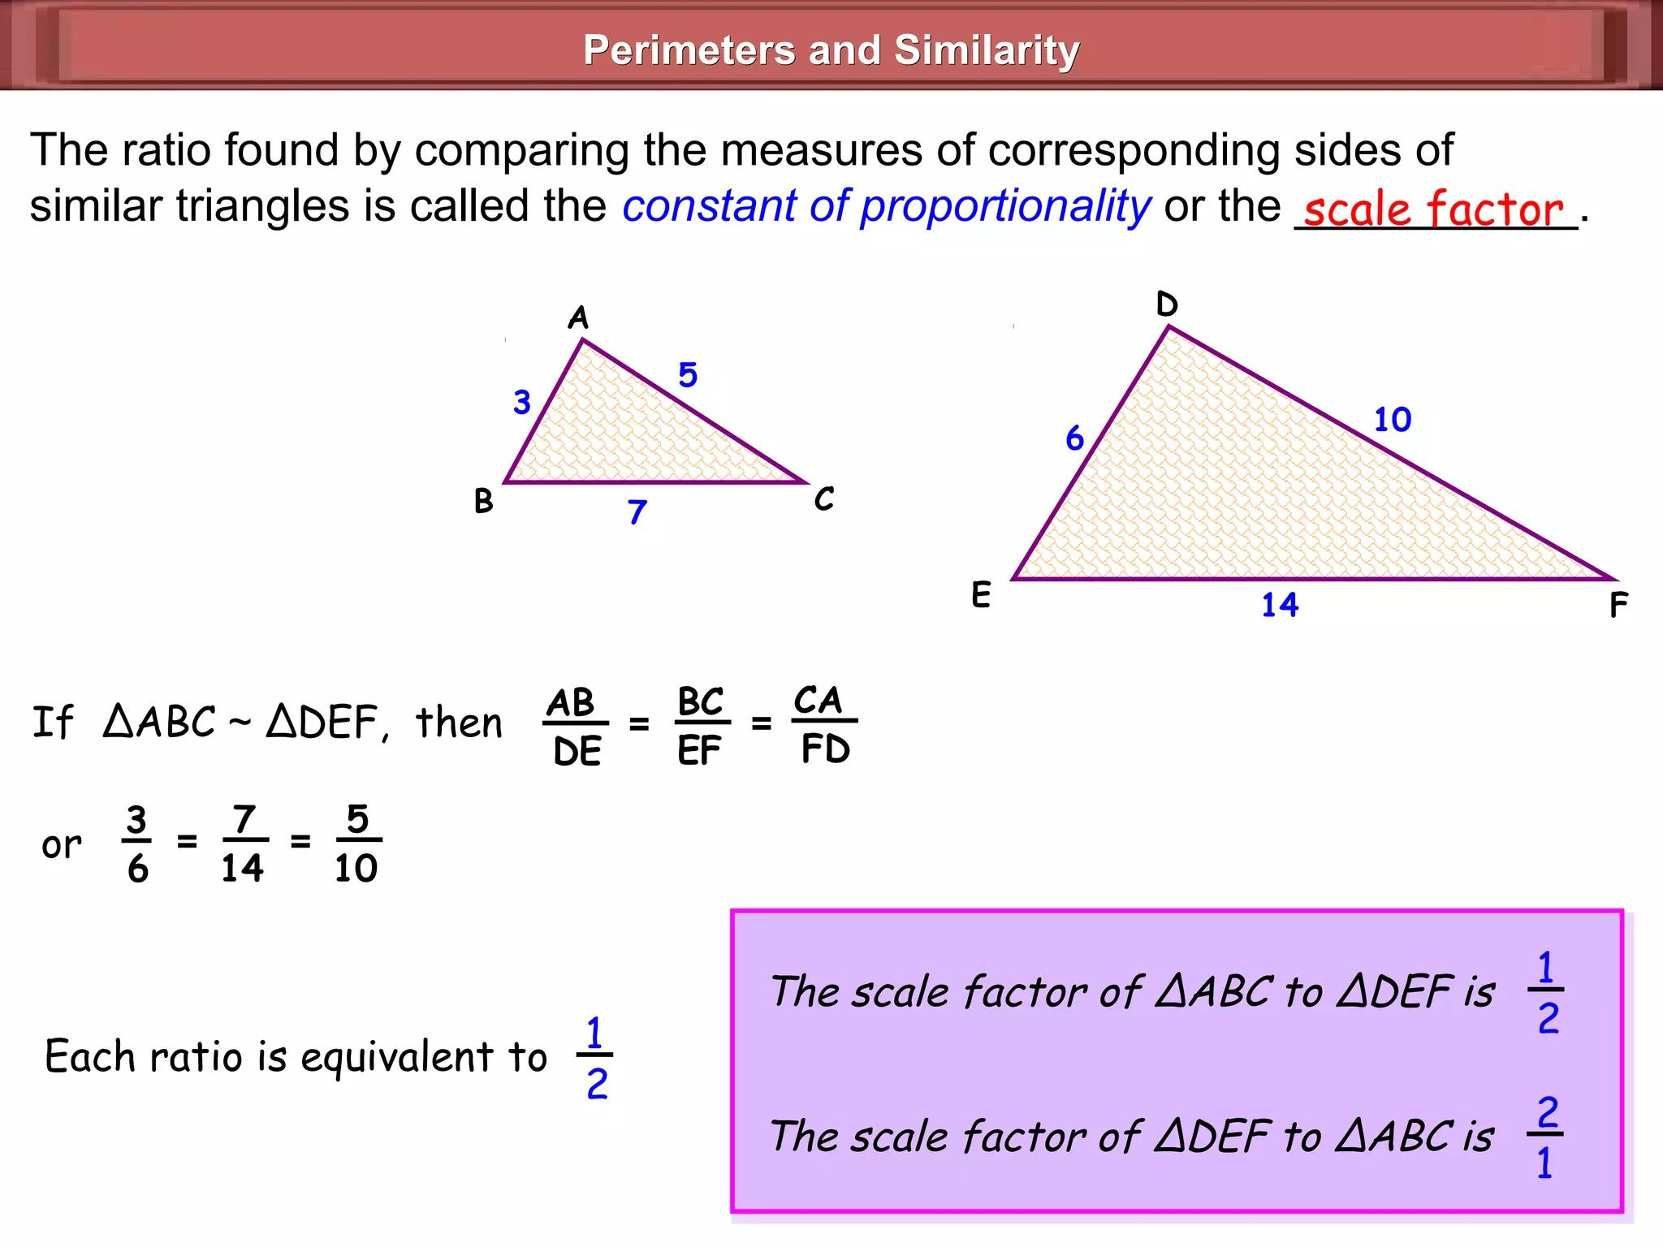
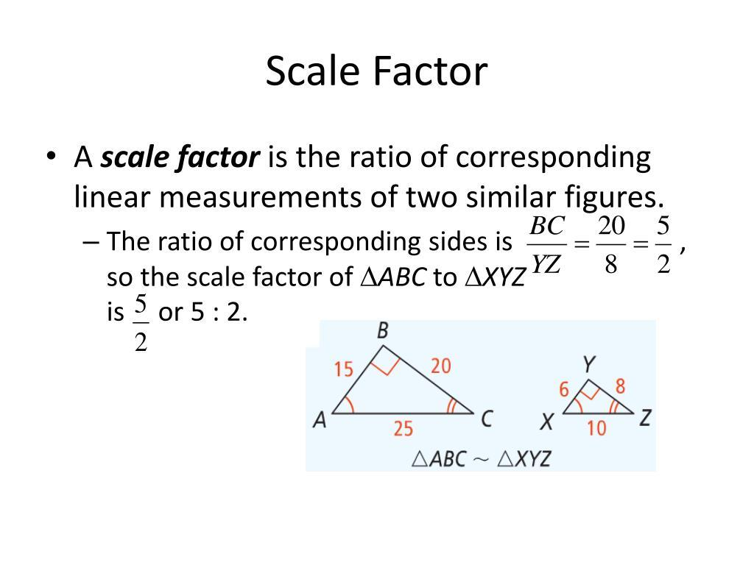

Purpose
# Source: AI Source: Provided by: [Data Path: Persons Table -> ID Column: 1, Name_En Column: Motasem Essam] -> From: [ChatGPT] on [7/25/2026]
Geometric proportionality is used to:
- Compare lengths and distances.
- Determine unknown side lengths.
- Analyze similar figures.
- Calculate scale factors.
- Solve geometric problems.
- Construct scaled drawings.
- Analyze maps and models.
- Support architecture and engineering design.
- Calculate indirect measurements.

Fundamental Idea
# Source: AI Source: Provided by: [Data Path: Persons Table -> ID Column: 1, Name_En Column: Motasem Essam] -> From: [ChatGPT] on [7/25/2026]
If two geometric quantities maintain the same ratio, they are proportional.
For example:
$$\frac{2}{4}=\frac{3}{6}=\frac{5}{10}$$
All these ratios are equal to:
$$\frac{1}{2}$$
Therefore, the quantities are proportional.
$$\boxed{2:4=3:6=5:10}$$

Constant of Proportionality
# Source: AI Source: Provided by: [Data Path: Persons Table -> ID Column: 1, Name_En Column: Motasem Essam] -> From: [ChatGPT] on [7/25/2026]
The constant of proportionality is the fixed ratio between two proportional quantities.
If:
$$a∝b$$
then:
$$\boxed{\frac{a}{b}=k}$$
or:
$$\boxed{a=kb}$$
where $k$ is constant.
Example
Suppose:
$$a=6$$
and:
$$b=3$$
Then:
$$k=\frac{a}{b} \\ k=\frac{6}{3}=2$$
Therefore:
$$\boxed{a=2b}$$

Proportional Line Segments
# Source: AI Source: Provided by: [Data Path: Persons Table -> ID Column: 1, Name_En Column: Motasem Essam] -> From: [ChatGPT] on [7/25/2026]
Two line segments are proportional when their lengths have a constant ratio.
For example:
$$AB=4$$
and:
$$CD=8$$
Then:
$$\frac{AB}{CD}=\frac{4}{8} \\ \boxed{\frac{AB}{CD}=\frac{1}{2}}$$
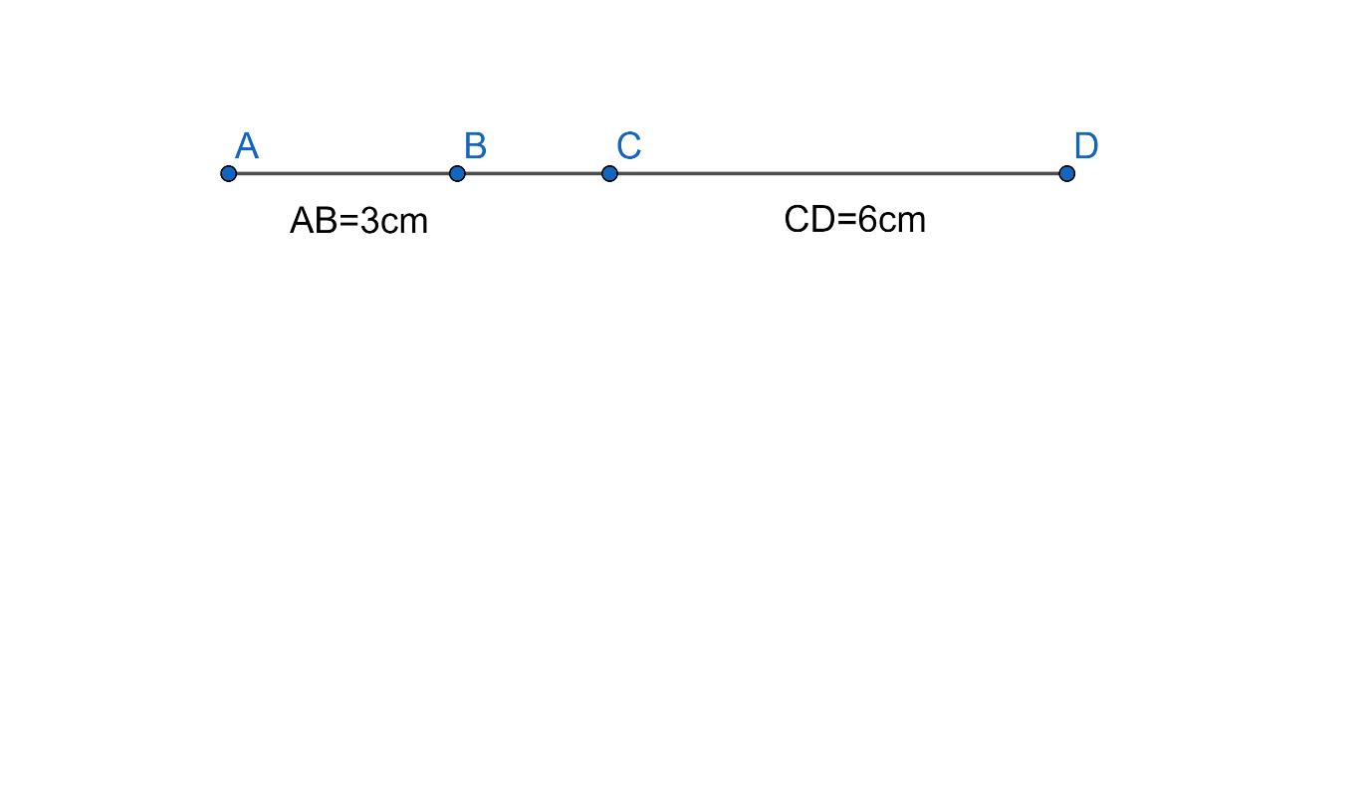
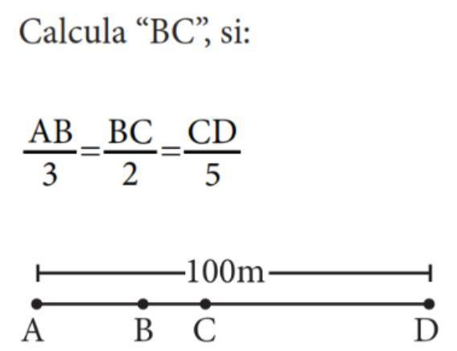
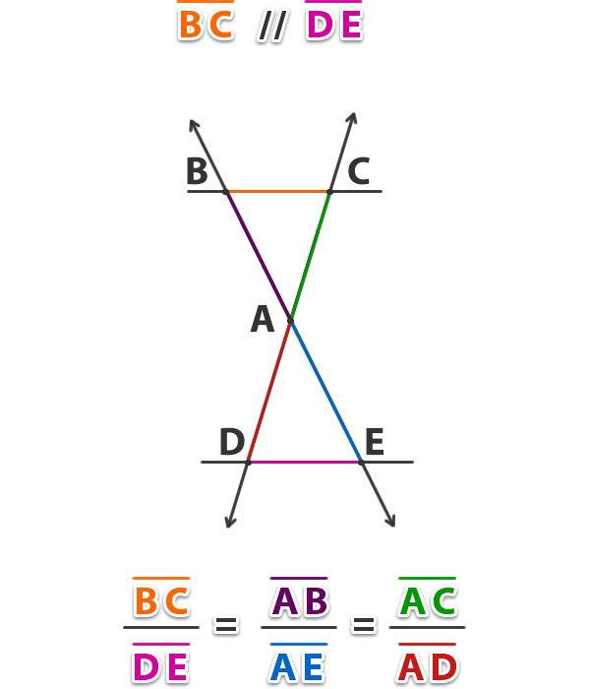

Proportional Sides of Similar Figures
# Source: AI Source: Provided by: [Data Path: Persons Table -> ID Column: 1, Name_En Column: Motasem Essam] -> From: [ChatGPT] on [7/25/2026]
One of the most important applications of proportionality is similar figures.
If two triangles are similar:
$$△ABC∼△DEF$$
then corresponding sides are proportional:
$$\boxed{\frac{AB}{DE}=\frac{BC}{EF}=\frac{AC}{DF}}$$
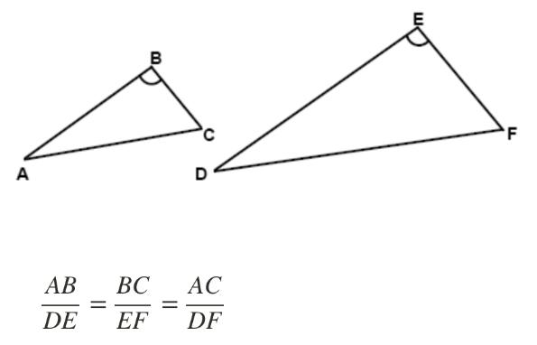
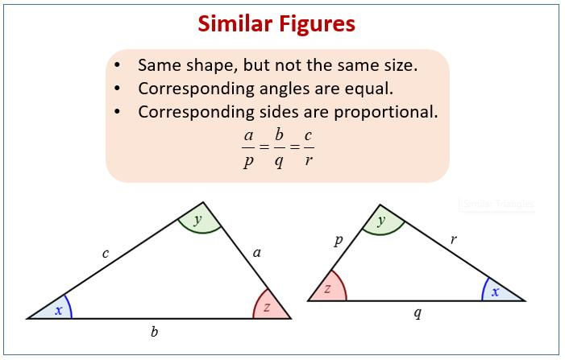
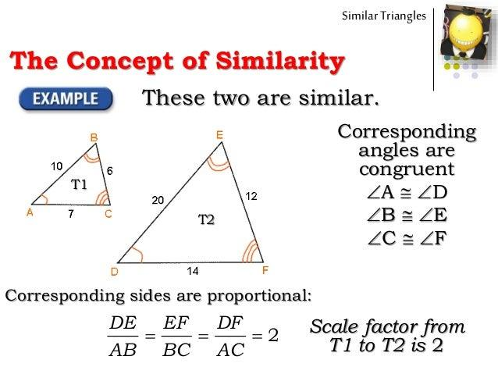
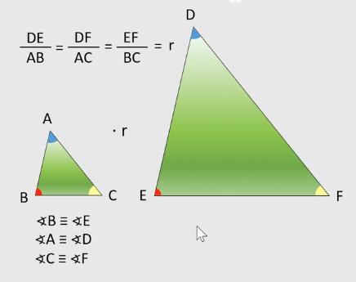
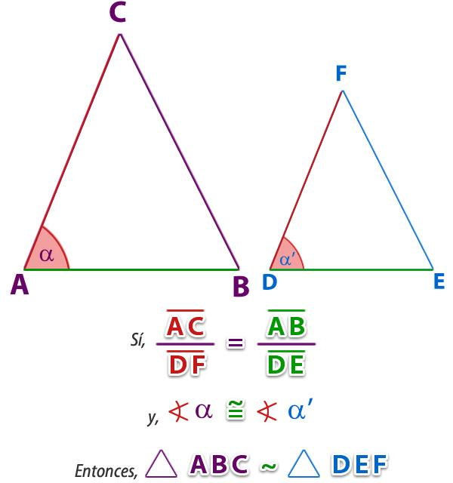

Example — Similar Triangles
# Source: AI Source: Provided by: [Data Path: Persons Table -> ID Column: 1, Name_En Column: Motasem Essam] -> From: [ChatGPT] on [7/25/2026]
Suppose two triangles have corresponding sides:
$$AB=4 \\ DE=8$$
and:
$$BC=5 \\ EF=10$$
Then:
$$\frac{AB}{DE}=\frac{4}{8}=\frac{1}{2}$$
and:
$$\frac{BC}{EF}=\frac{5}{10}=\frac{1}{2}$$
Therefore:
$$\boxed{\frac{AB}{DE}=\frac{BC}{EF}}$$
The corresponding sides are proportional.

Scale Factor
# Source: AI Source: Provided by: [Data Path: Persons Table -> ID Column: 1, Name_En Column: Motasem Essam] -> From: [ChatGPT] on [7/25/2026]
A scale factor describes how much a geometric figure has been enlarged or reduced.
If an original length is $a$ and the corresponding new length is $b$:
$$\boxed{k=\frac{b}{a}}$$
where $k$ is the scale factor.
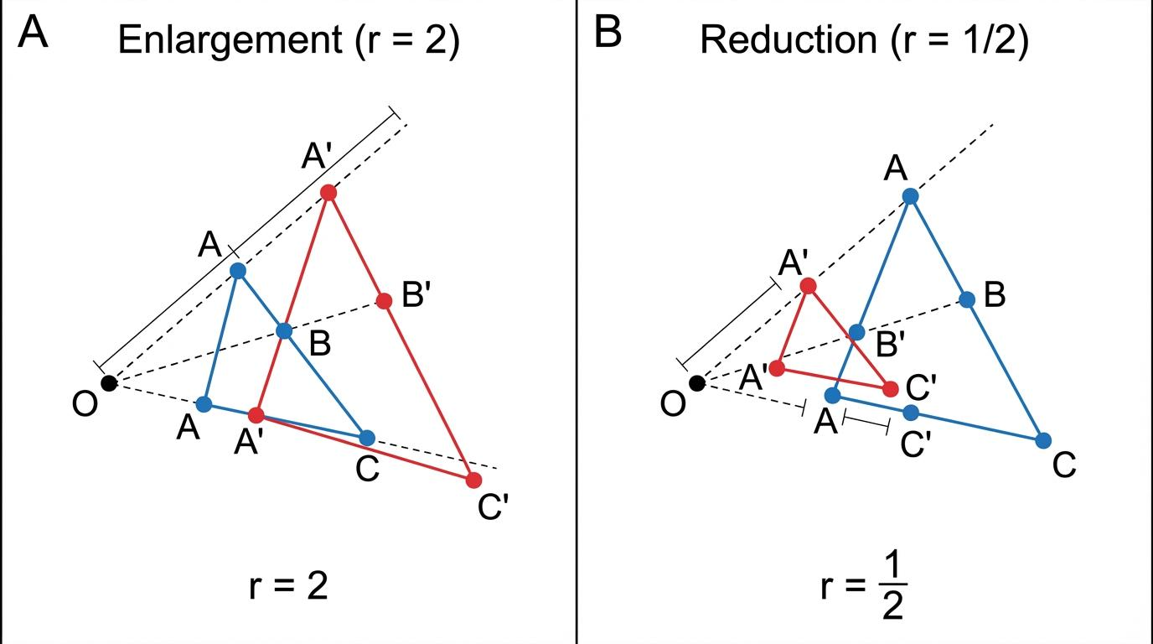
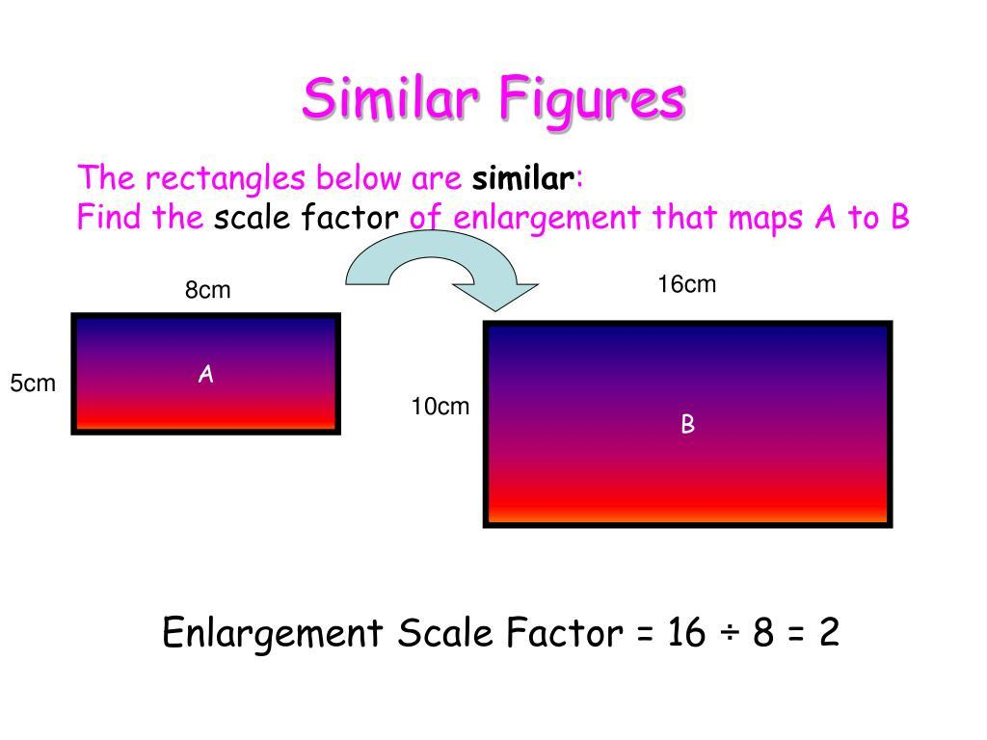
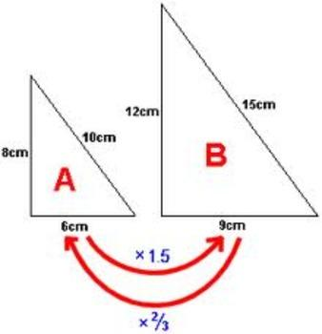
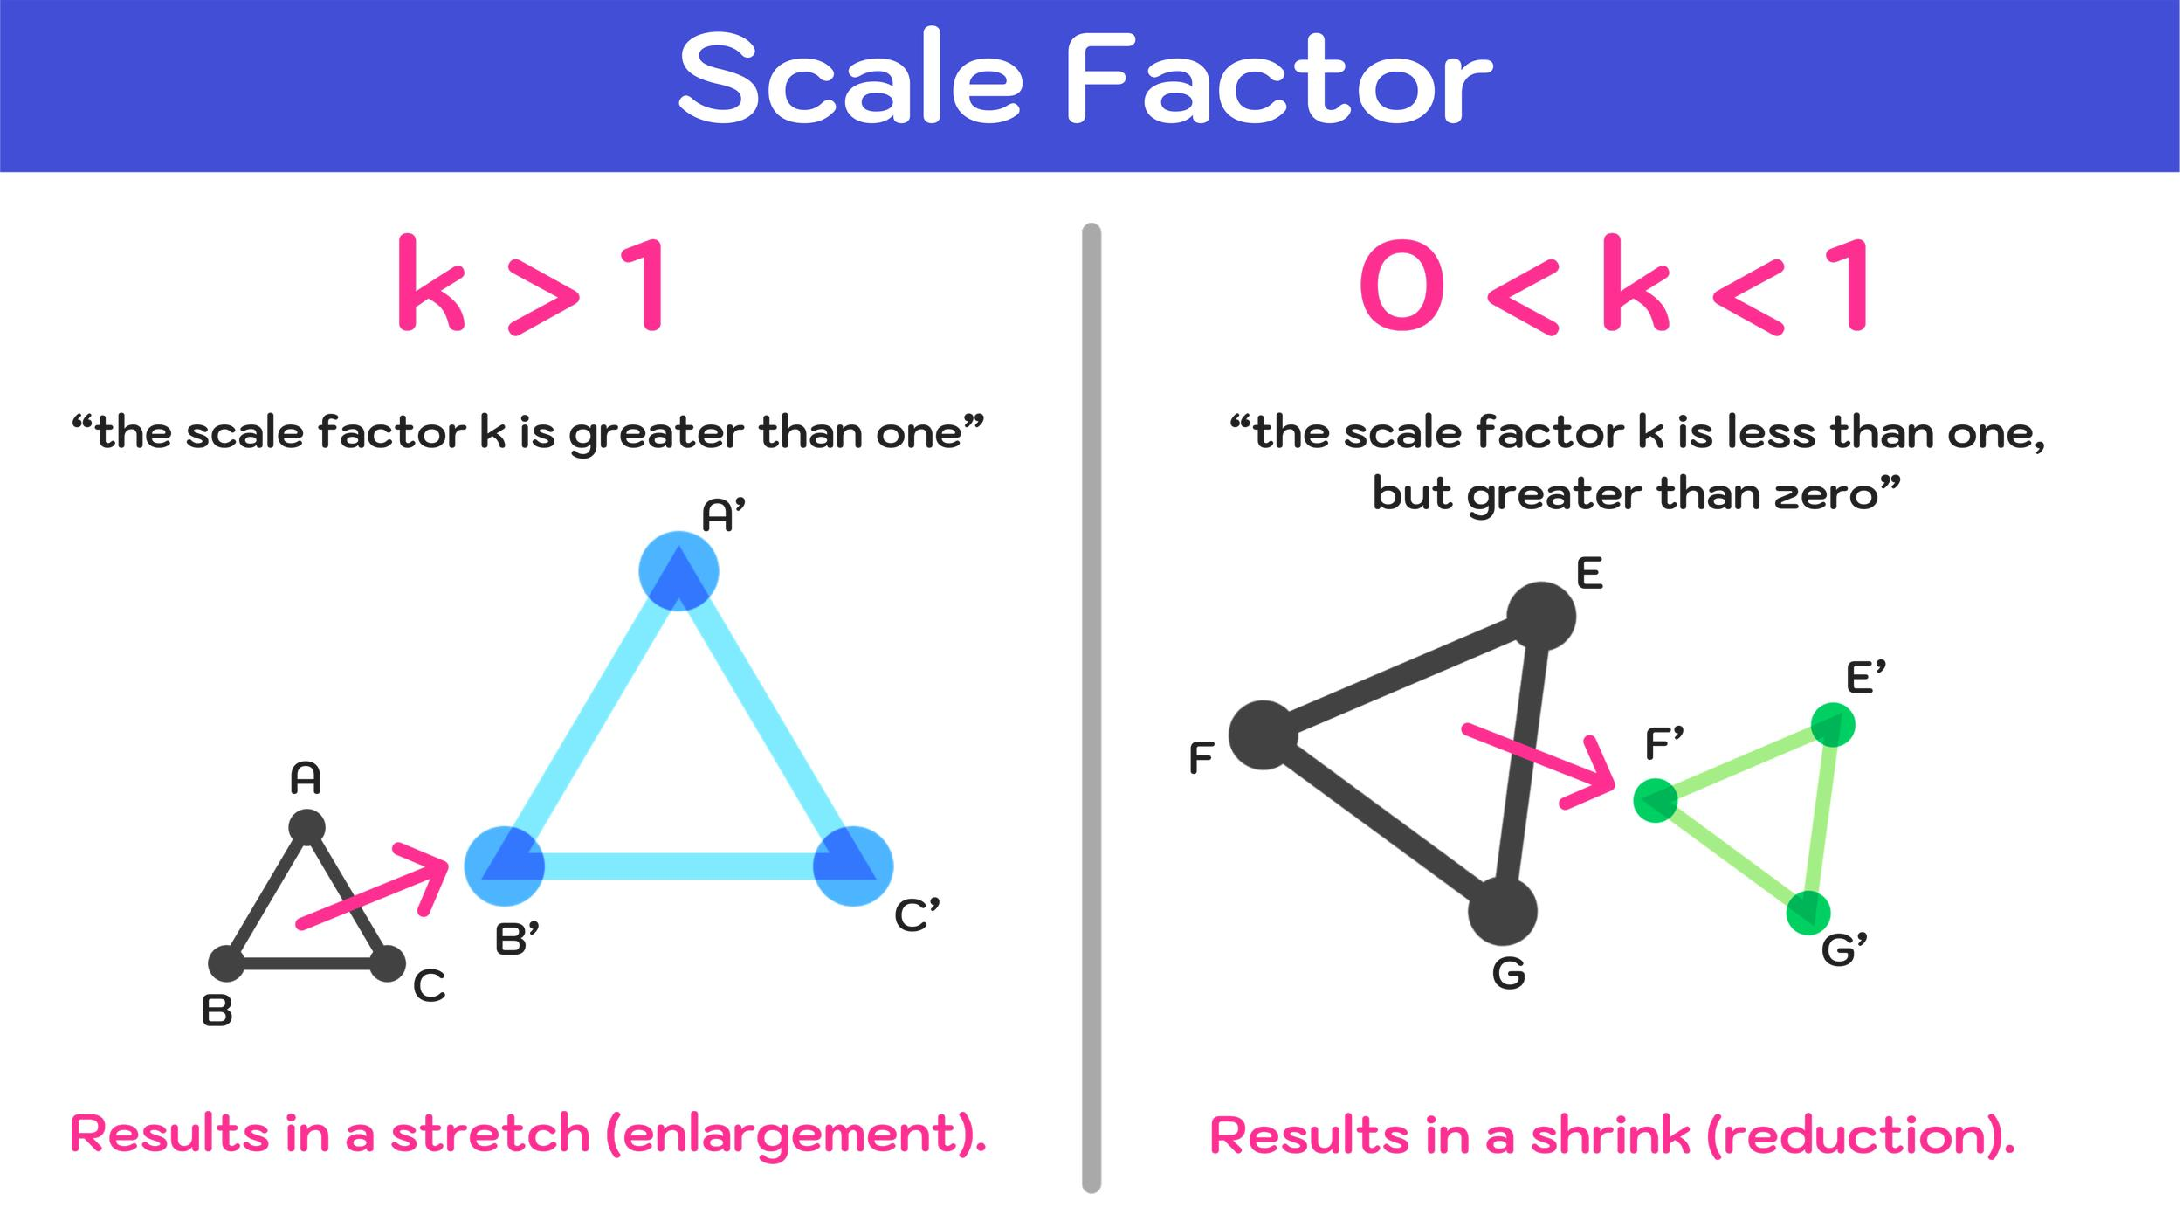
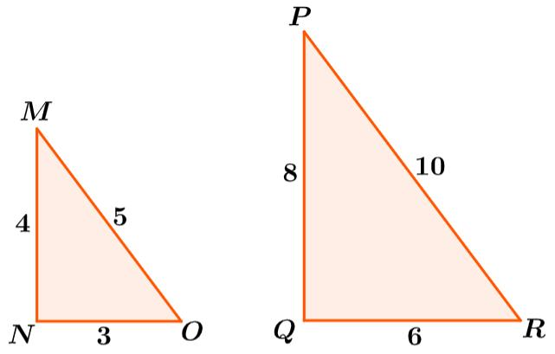
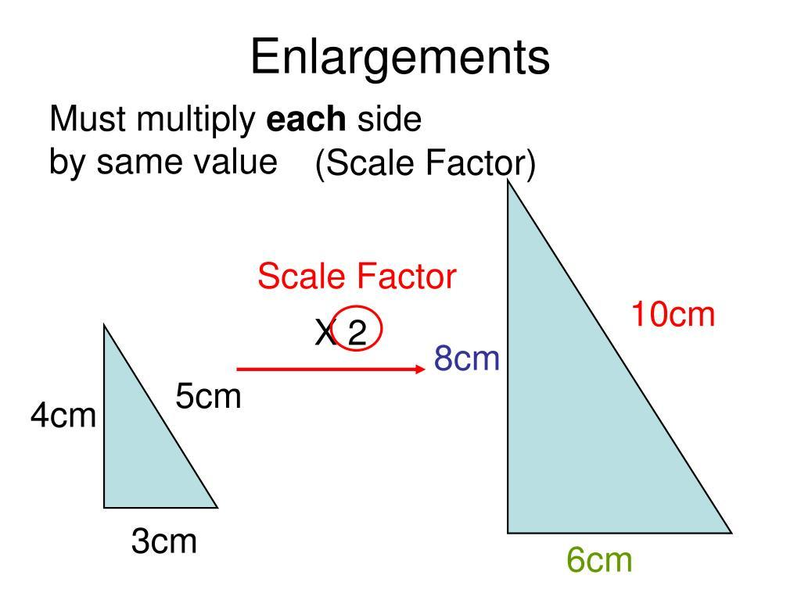
Example
Original side:
$$5$$
New side:
$$15$$
Therefore:
$$k=\frac{15}{5} \\ \boxed{k=3}$$
The new figure is 3 times larger in linear dimensions.

Enlargement
# Source: AI Source: Provided by: [Data Path: Persons Table -> ID Column: 1, Name_En Column: Motasem Essam] -> From: [ChatGPT] on [7/25/2026]
When:
$$k>1$$
the figure is enlarged.
For example:
$$k=2$$
means every corresponding length becomes twice as large.
$$\boxed{\text{New Length}=2\left(\text{Original Length}\right)}$$

Reduction
# Source: AI Source: Provided by: [Data Path: Persons Table -> ID Column: 1, Name_En Column: Motasem Essam] -> From: [ChatGPT] on [7/25/2026]
When:
$$0<k<1$$
the figure is reduced.
For example:
$$k=\frac{1}{2}$$
means every corresponding length becomes half as large.
$$\boxed{\text{New Length}=\frac{1}{2}\left(\text{Original Length}\right)}$$

Proportionality in Triangles
# Source: AI Source: Provided by: [Data Path: Persons Table -> ID Column: 1, Name_En Column: Motasem Essam] -> From: [ChatGPT] on [7/25/2026]
A fundamental result in geometry is the Triangle Proportionality Theorem.
If a line is parallel to one side of a triangle, it divides the other two sides proportionally.
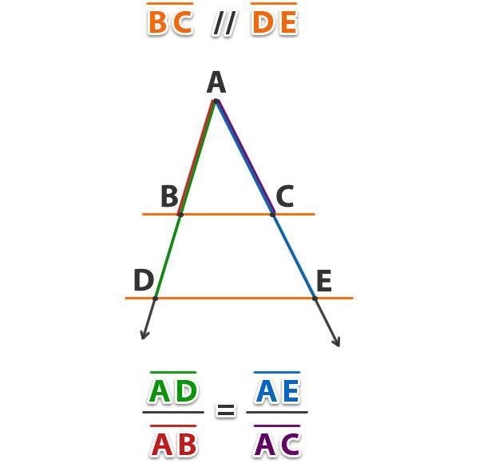
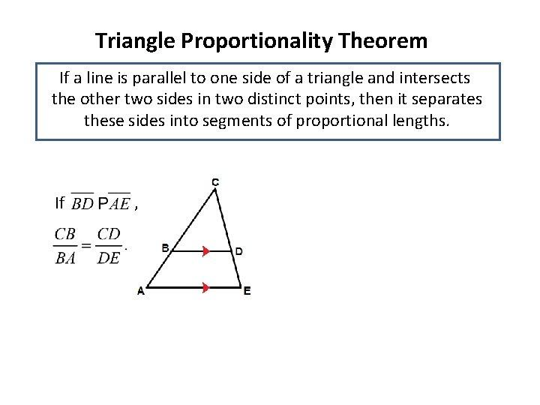
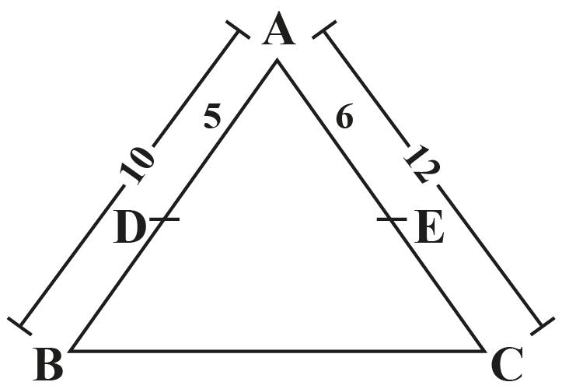
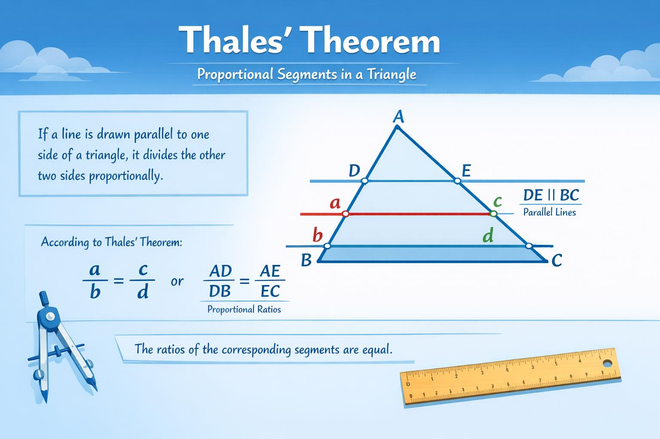
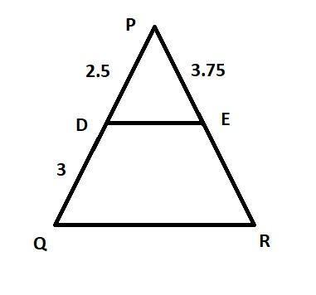
For example, if:
$$DE∥BC$$
then:
$$\boxed{\frac{AD}{DB}=\frac{AE}{EC}}$$
This relationship is widely used to determine unknown lengths.

Example — Triangle Proportionality
# Source: AI Source: Provided by: [Data Path: Persons Table -> ID Column: 1, Name_En Column: Motasem Essam] -> From: [ChatGPT] on [7/25/2026]
Suppose:
$$AD=3 \\ DB=6 \\ AE=4$$
and $EC=x$.
Because the corresponding segments are proportional:
$$\frac{AD}{DB}=\frac{AE}{EC}$$
Therefore:
$$\frac{3}{6}=\frac{4}{x}$$
Cross-multiply:
$$3x=24 \\ \boxed{x=8}$$

Proportionality in Rectangles
# Source: AI Source: Provided by: [Data Path: Persons Table -> ID Column: 1, Name_En Column: Motasem Essam] -> From: [ChatGPT] on [7/25/2026]
If two rectangles are similar, their corresponding lengths and widths are proportional.
For example:
Rectangle 1:
$$4×6$$
Rectangle 2:
$$8×12$$
Then:
$$\frac{8}{4}=2$$
and:
$$\frac{12}{6}=2$$
Therefore, the corresponding dimensions have the same scale factor:
$$\boxed{k=2}$$
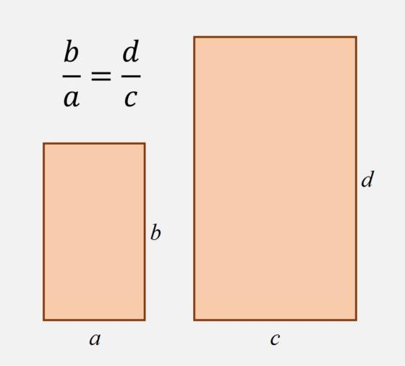
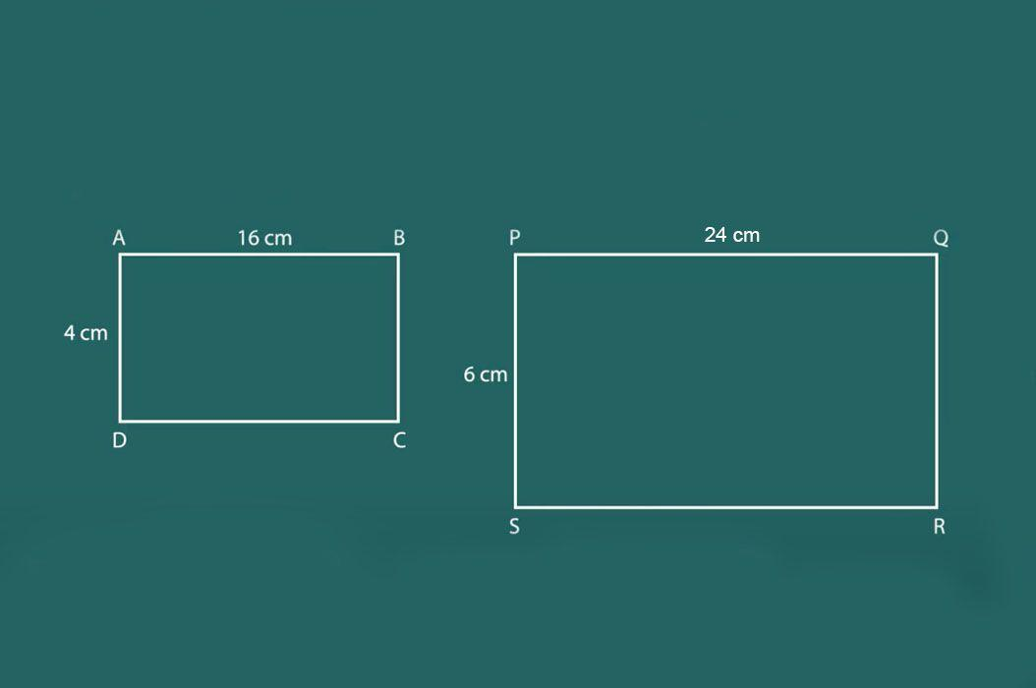
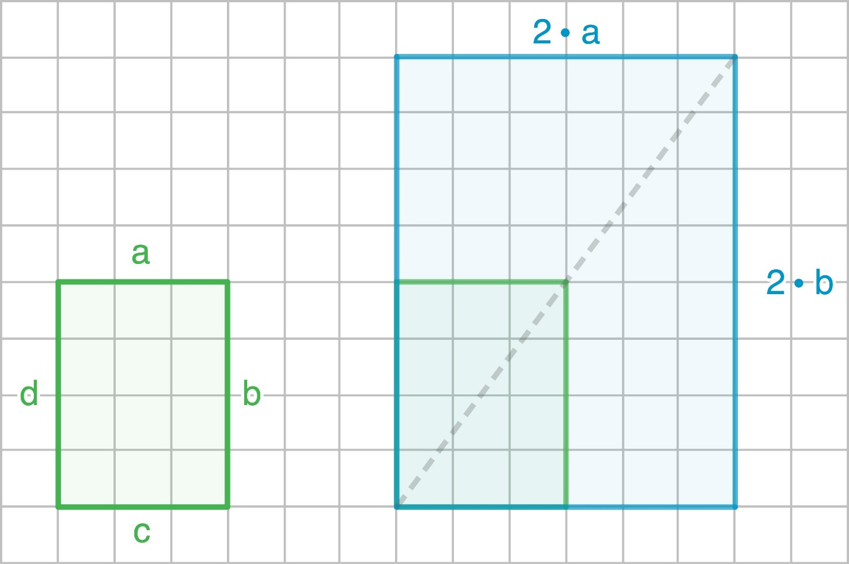
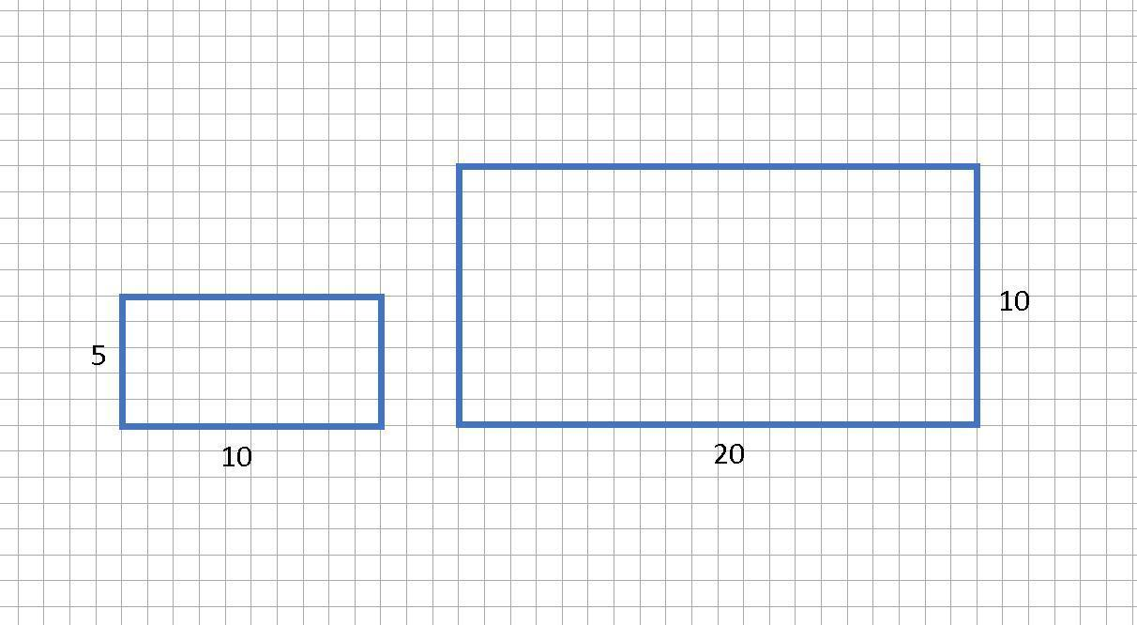
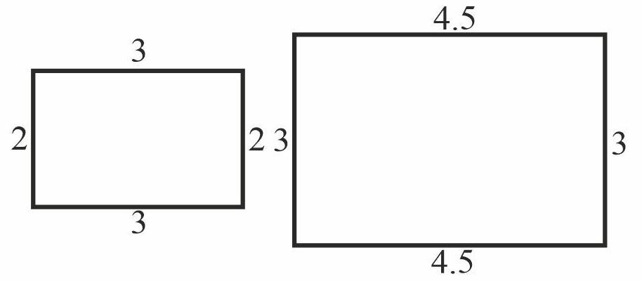

Proportionality and Area
# Source: AI Source: Provided by: [Data Path: Persons Table -> ID Column: 1, Name_En Column: Motasem Essam] -> From: [ChatGPT] on [7/25/2026]
When two similar figures have a linear scale factor $k$, their areas are proportional to the square of the scale factor.
$$\boxed{\frac{A_{2}}{A_{1}}=k^{2}}$$
Example
If:
$$k=3$$
then:
$$\frac{A_{2}}{A_{1}}=3^{2}=9$$
So the new area is:
$$\boxed{9\text{ times the original area}}$$

Proportionality and Volume
# Source: AI Source: Provided by: [Data Path: Persons Table -> ID Column: 1, Name_En Column: Motasem Essam] -> From: [ChatGPT] on [7/25/2026]
For similar three-dimensional figures, volume is proportional to the cube of the linear scale factor.
$$\boxed{\frac{V_{2}}{V_{1}}=k^{3}}$$
For example, if:
$$k=2$$
then:
$$\frac{V_{2}}{V_{1}}=2^{3}=8$$
So the new volume is:
$$\boxed{8\text{ times the original volume}}$$

Proportionality of Perimeters
# Source: AI Source: Provided by: [Data Path: Persons Table -> ID Column: 1, Name_En Column: Motasem Essam] -> From: [ChatGPT] on [7/25/2026]
For similar figures, perimeters are proportional to the linear scale factor:
$$\boxed{\frac{P_{2}}{P_{1}}=k}$$
If:
$$k=3$$
then:
$$P_{2}=3P_{1}$$

Proportionality of Areas and Perimeters
# Source: AI Source: Provided by: [Data Path: Persons Table -> ID Column: 1, Name_En Column: Motasem Essam] -> From: [ChatGPT] on [7/25/2026]
For similar figures:
$$\boxed{\text{Length Ratio}=k} \\ \boxed{\text{Perimeter Ratio}=k} \\ \boxed{\text{Area Ratio}=k^{2}}$$
For similar solids:
$$\boxed{\text{Volume Ratio}=k^{3}}$$

Direct Proportionality
# Source: AI Source: Provided by: [Data Path: Persons Table -> ID Column: 1, Name_En Column: Motasem Essam] -> From: [ChatGPT] on [7/25/2026]
Two quantities are directly proportional when one increases or decreases by the same factor as the other.
$$\boxed{y=kx}$$
Example
If:
$$y=2x$$
then:
$$x=3⇒y=6$$
and:
$$x=5⇒y=10$$
The ratio remains constant:
$$\boxed{\frac{y}{x}=2}$$

Inverse Proportionality
# Source: AI Source: Provided by: [Data Path: Persons Table -> ID Column: 1, Name_En Column: Motasem Essam] -> From: [ChatGPT] on [7/25/2026]
Two quantities are inversely proportional when one increases while the other decreases so that their product remains constant.
$$\boxed{xy=k}$$
or:
$$\boxed{y=\frac{k}{x}}$$
Although inverse proportionality is less central to basic geometric similarity, it can appear in geometric and physical applications.

Proportionality in Maps
# Source: AI Source: Provided by: [Data Path: Persons Table -> ID Column: 1, Name_En Column: Motasem Essam] -> From: [ChatGPT] on [7/25/2026]
Maps use proportional relationships between actual distances and represented distances.
For example:
$$1\text{ cm}=10\text{ km}$$
If two locations are $4$ cm apart on the map:
$$4×10=40$$
Therefore:
$$\boxed{40\text{ km}}$$
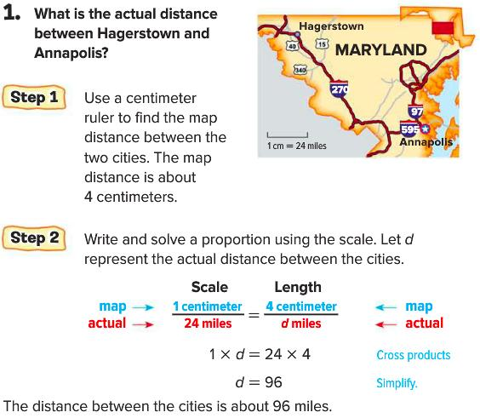
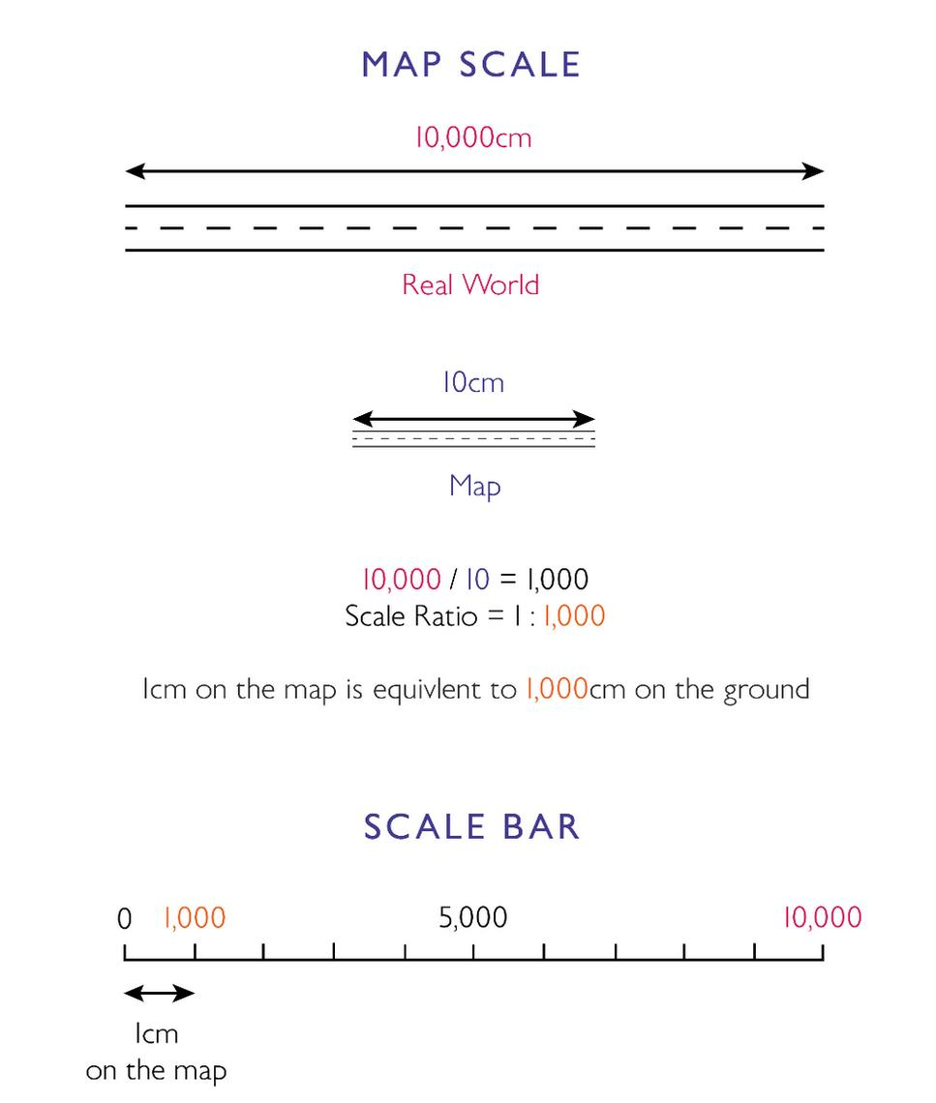
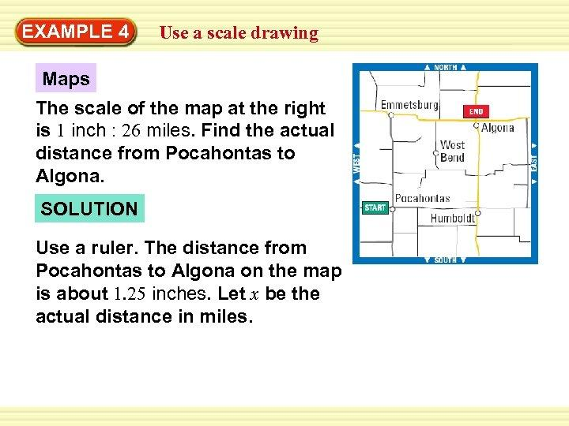
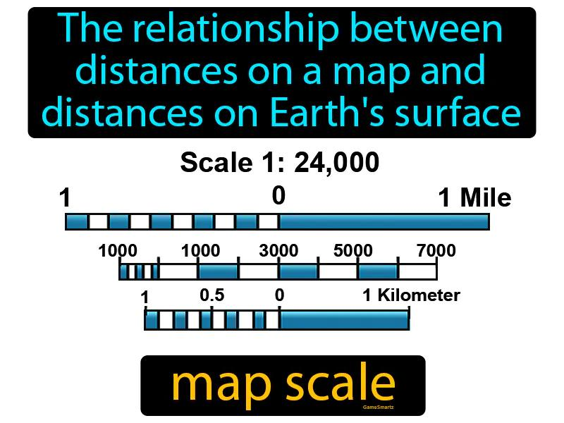
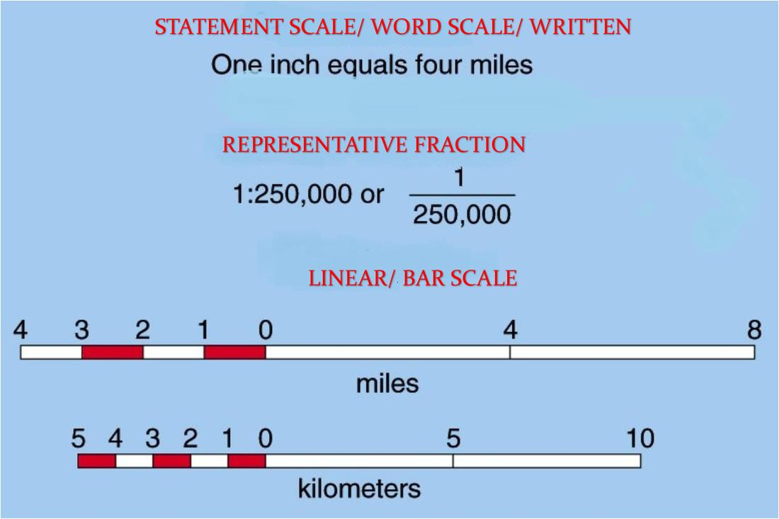

Proportionality in Models
# Source: AI Source: Provided by: [Data Path: Persons Table -> ID Column: 1, Name_En Column: Motasem Essam] -> From: [ChatGPT] on [7/25/2026]
Architectural and engineering models use scale factors.
For example:
$$1:100$$
means:
$$1\text{ unit on the model}=100\text{ units in reality}$$
If a model wall is:
$$5\text{ cm}$$
then the actual wall is:
$$5×100=500\text{ cm} \\ \boxed{5\text{ m}}$$
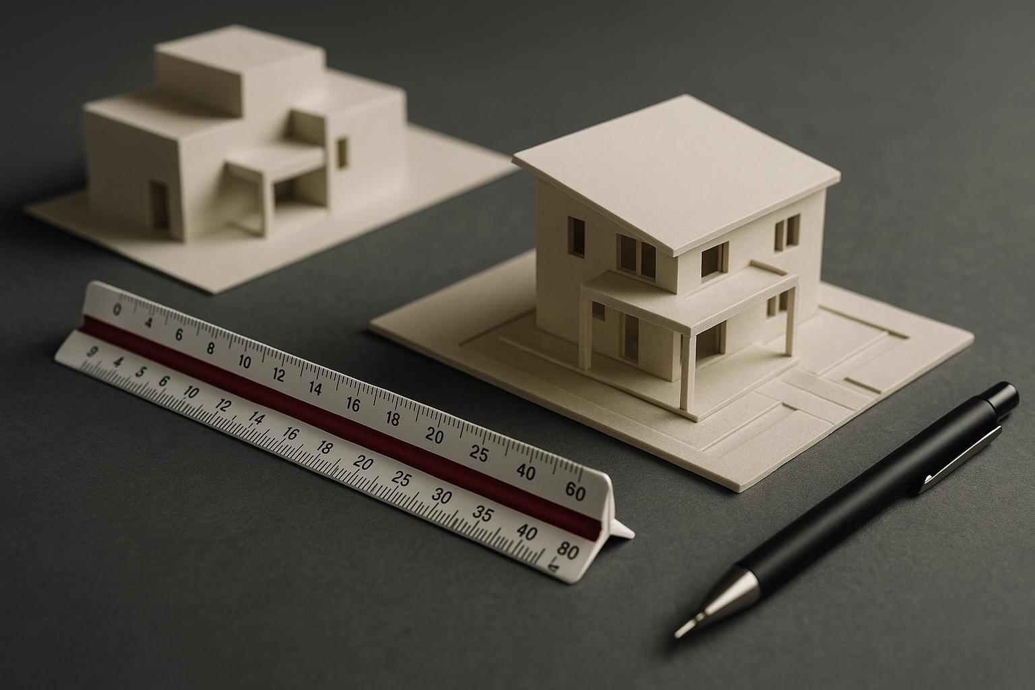
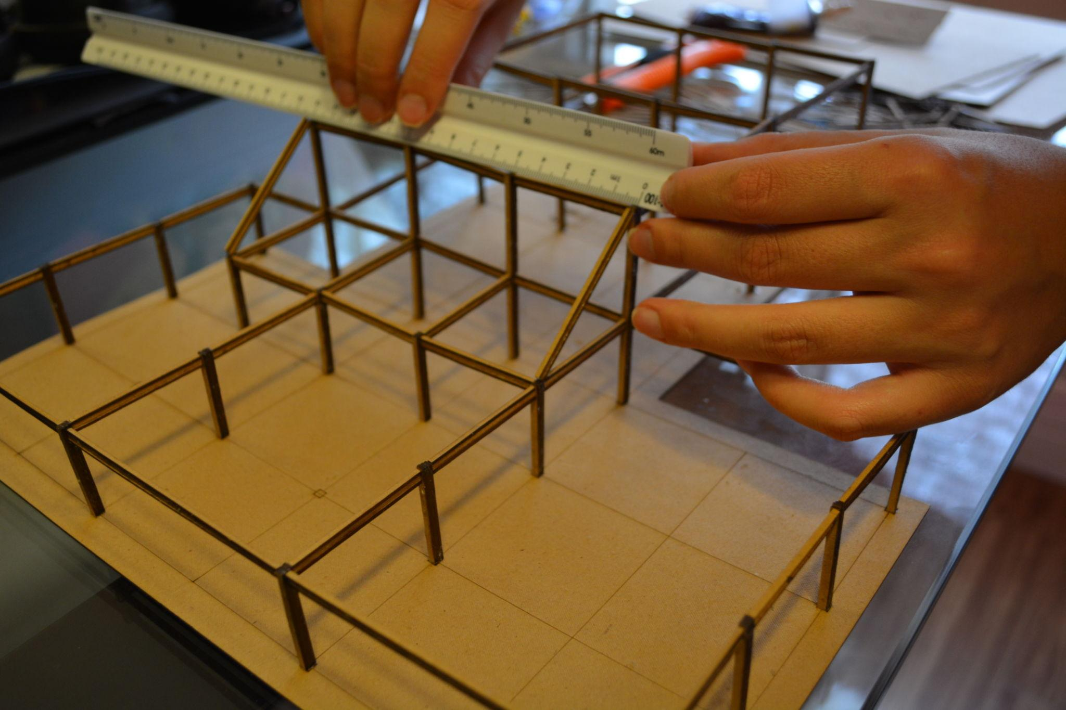
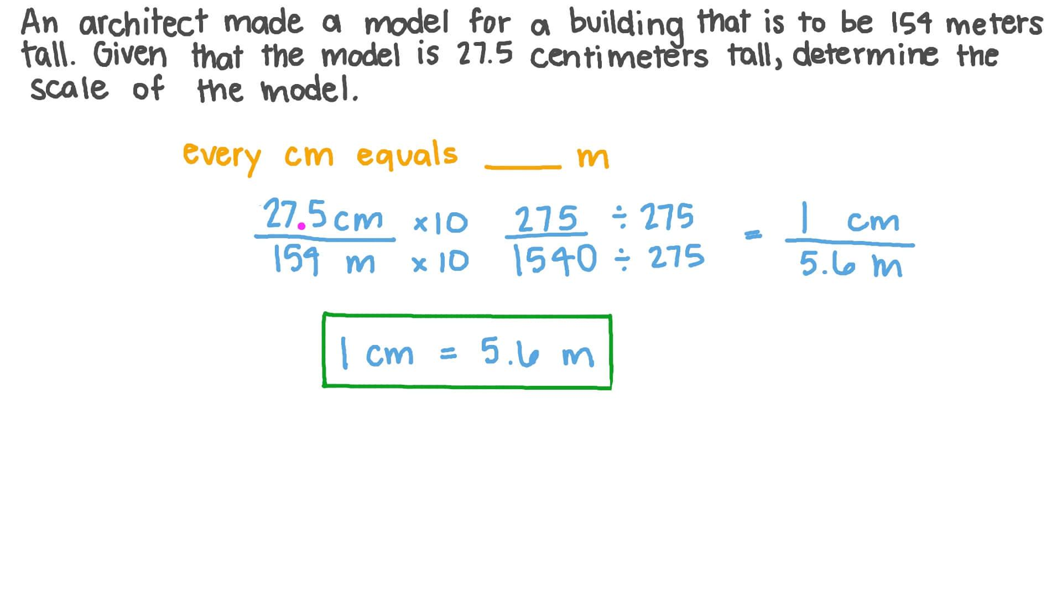
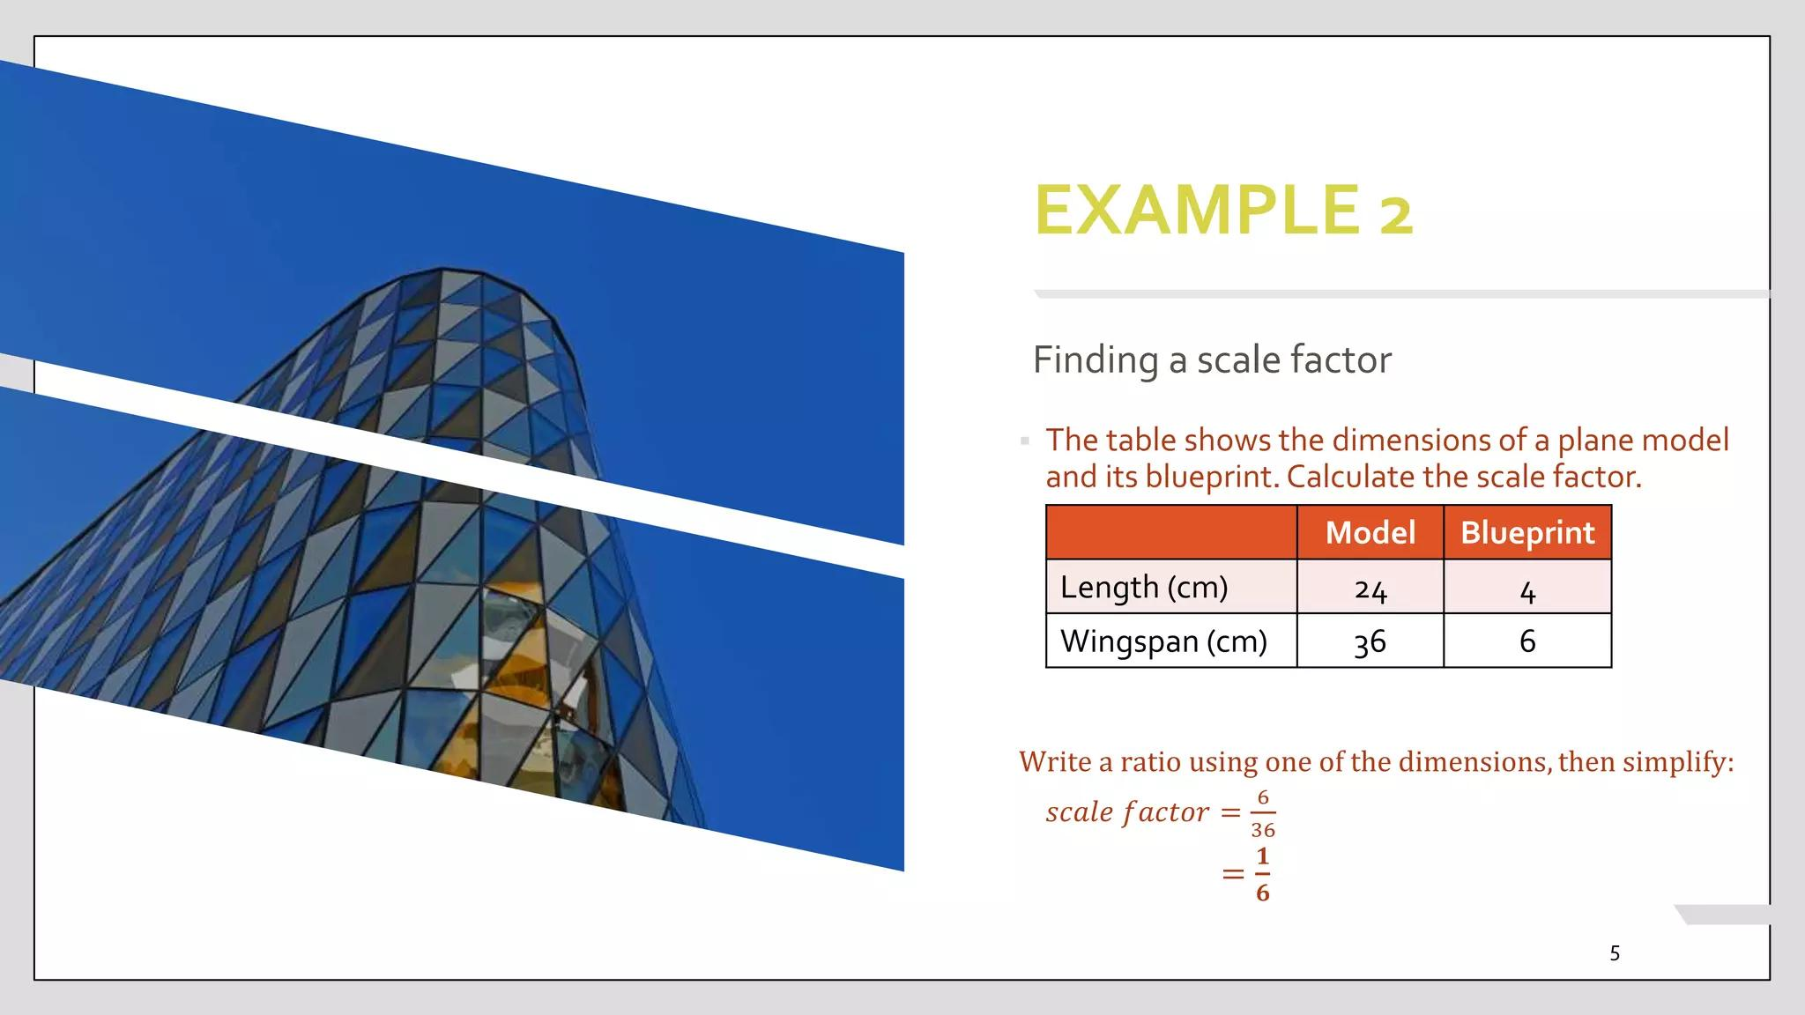
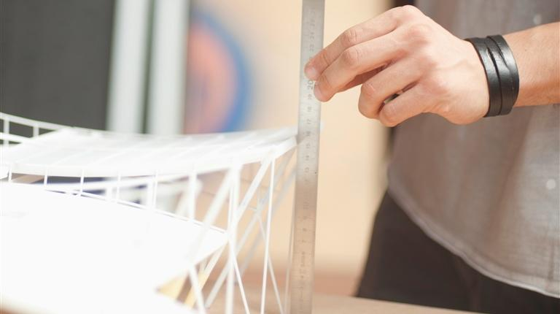

Proportionality in Coordinate Geometry
# Source: AI Source: Provided by: [Data Path: Persons Table -> ID Column: 1, Name_En Column: Motasem Essam] -> From: [ChatGPT] on [7/25/2026]
Proportionality can also be used with coordinates.
For example, if a point divides a line segment in a fixed ratio, its coordinates can be determined using a section formula.
For points:
$$A\left(x_{1},y_{1}\right)$$
and:
$$B\left(x_{2},y_{2}\right)$$
a point dividing $AB$ in a ratio can be calculated using weighted averages of the coordinates.

Proportionality vs. Equality
# Source: AI Source: Provided by: [Data Path: Persons Table -> ID Column: 1, Name_En Column: Motasem Essam] -> From: [ChatGPT] on [7/25/2026]
These concepts are different.
Equality
Two quantities have exactly the same value:
$$\boxed{a=b}$$
Proportionality
Two quantities have a constant ratio:
$$\boxed{\frac{a}{b}=k}$$
For example:
$$4≠8$$
but:
$$\frac{4}{8}=\frac{1}{2}$$
So $4$ and $8$ are proportional, but they are not equal.

Proportionality vs. Congruence
# Source: AI Source: Provided by: [Data Path: Persons Table -> ID Column: 1, Name_En Column: Motasem Essam] -> From: [ChatGPT] on [7/25/2026]
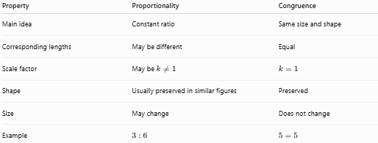
Property | Proportionality | Congruence
Main idea | Constant ratio | Same size and shape
Corresponding lengths | May be different | Equal
Scale factor | May be $k≠1$ | $$k=1$$
Shape | Usually preserved in similar figures | Preserved
Size | May change | Does not change
Example | $$3:6$$ | $$5=5$$

Proportionality vs. Similarity
# Source: AI Source: Provided by: [Data Path: Persons Table -> ID Column: 1, Name_En Column: Motasem Essam] -> From: [ChatGPT] on [7/25/2026]
Proportionality describes a constant ratio between quantities.
Similarity describes figures that have the same shape but may have different sizes.
For similar figures, proportionality exists between corresponding lengths:
$$\boxed{\frac{a_{1}}{a_{2}}=\frac{b_{1}}{b_{2}}=\frac{c_{1}}{c_{2}}}$$
Therefore, proportionality is one of the fundamental mathematical relationships used to establish and analyze similarity.

Real-World Examples
# Source: AI Source: Provided by: [Data Path: Persons Table -> ID Column: 1, Name_En Column: Motasem Essam] -> From: [ChatGPT] on [7/25/2026]
Geometric proportionality appears in:
- Maps and cartography.
- Architectural drawings.
- Engineering models.
- Scale models.
- Photography.
- Computer graphics.
- CAD.
- Surveying.
- Construction.
- Mechanical design.
- Navigation.
- Scientific diagrams.

Applications
# Source: AI Source: Provided by: [Data Path: Persons Table -> ID Column: 1, Name_En Column: Motasem Essam] -> From: [ChatGPT] on [7/25/2026]
Geometric proportionality is important in:
- Plane Geometry
- Similarity
- Triangle Geometry
- Coordinate Geometry
- Trigonometry
- Architecture
- Engineering
- Surveying
- Cartography
- CAD
- Computer Graphics
- Manufacturing

Advantages
# Source: AI Source: Provided by: [Data Path: Persons Table -> ID Column: 1, Name_En Column: Motasem Essam] -> From: [ChatGPT] on [7/25/2026]
Studying geometric proportionality helps to:
- Find unknown lengths.
- Compare geometric quantities.
- Solve similar-figure problems.
- Calculate scale factors.
- Create accurate scaled drawings.
- Calculate inaccessible distances.
- Analyze maps and models.
- Simplify geometric calculations.

Limitations
# Source: AI Source: Provided by: [Data Path: Persons Table -> ID Column: 1, Name_En Column: Motasem Essam] -> From: [ChatGPT] on [7/25/2026]
Geometric proportionality:
- Requires a meaningful constant ratio.
- Does not mean that the quantities are equal.
- Must use corresponding quantities correctly.
- Does not automatically imply that arbitrary figures are similar.
- Area and volume do not scale by the same factor as lengths.

Key Points
# Source: AI Source: Provided by: [Data Path: Persons Table -> ID Column: 1, Name_En Column: Motasem Essam] -> From: [ChatGPT] on [7/25/2026]
- Geometric Proportionality describes a constant ratio between geometric quantities.
- Two quantities $a$ and $b$ are proportional when:
$$\boxed{\frac{a}{b}=k}$$
- Equivalently:
$$\boxed{a=kb}$$
- $k$ is the constant of proportionality or scale factor.
- Corresponding sides of similar figures are proportional.
- For similar figures:
$$\boxed{\text{Length Ratio}=k} \\ \boxed{\text{Perimeter Ratio}=k} \\ \boxed{\text{Area Ratio}=k^{2}}$$
- For similar solids:
$$\boxed{\text{Volume Ratio}=k^{3}}$$
- Proportionality is widely used in geometry, maps, models, architecture, engineering, CAD, and surveying.

Conclusion
# Source: AI Source: Provided by: [Data Path: Persons Table -> ID Column: 1, Name_En Column: Motasem Essam] -> From: [ChatGPT] on [7/25/2026]
Geometric Proportionality is a fundamental geometric relationship in which corresponding lengths, distances, or other quantities maintain a constant ratio. It provides the mathematical foundation for comparing geometric measurements, determining unknown lengths, establishing scale factors, and analyzing similar figures. Proportionality is especially important in similar triangles, scaled drawings, maps, models, architecture, engineering, surveying, CAD, and computer graphics, where accurate relationships between dimensions are essential.

